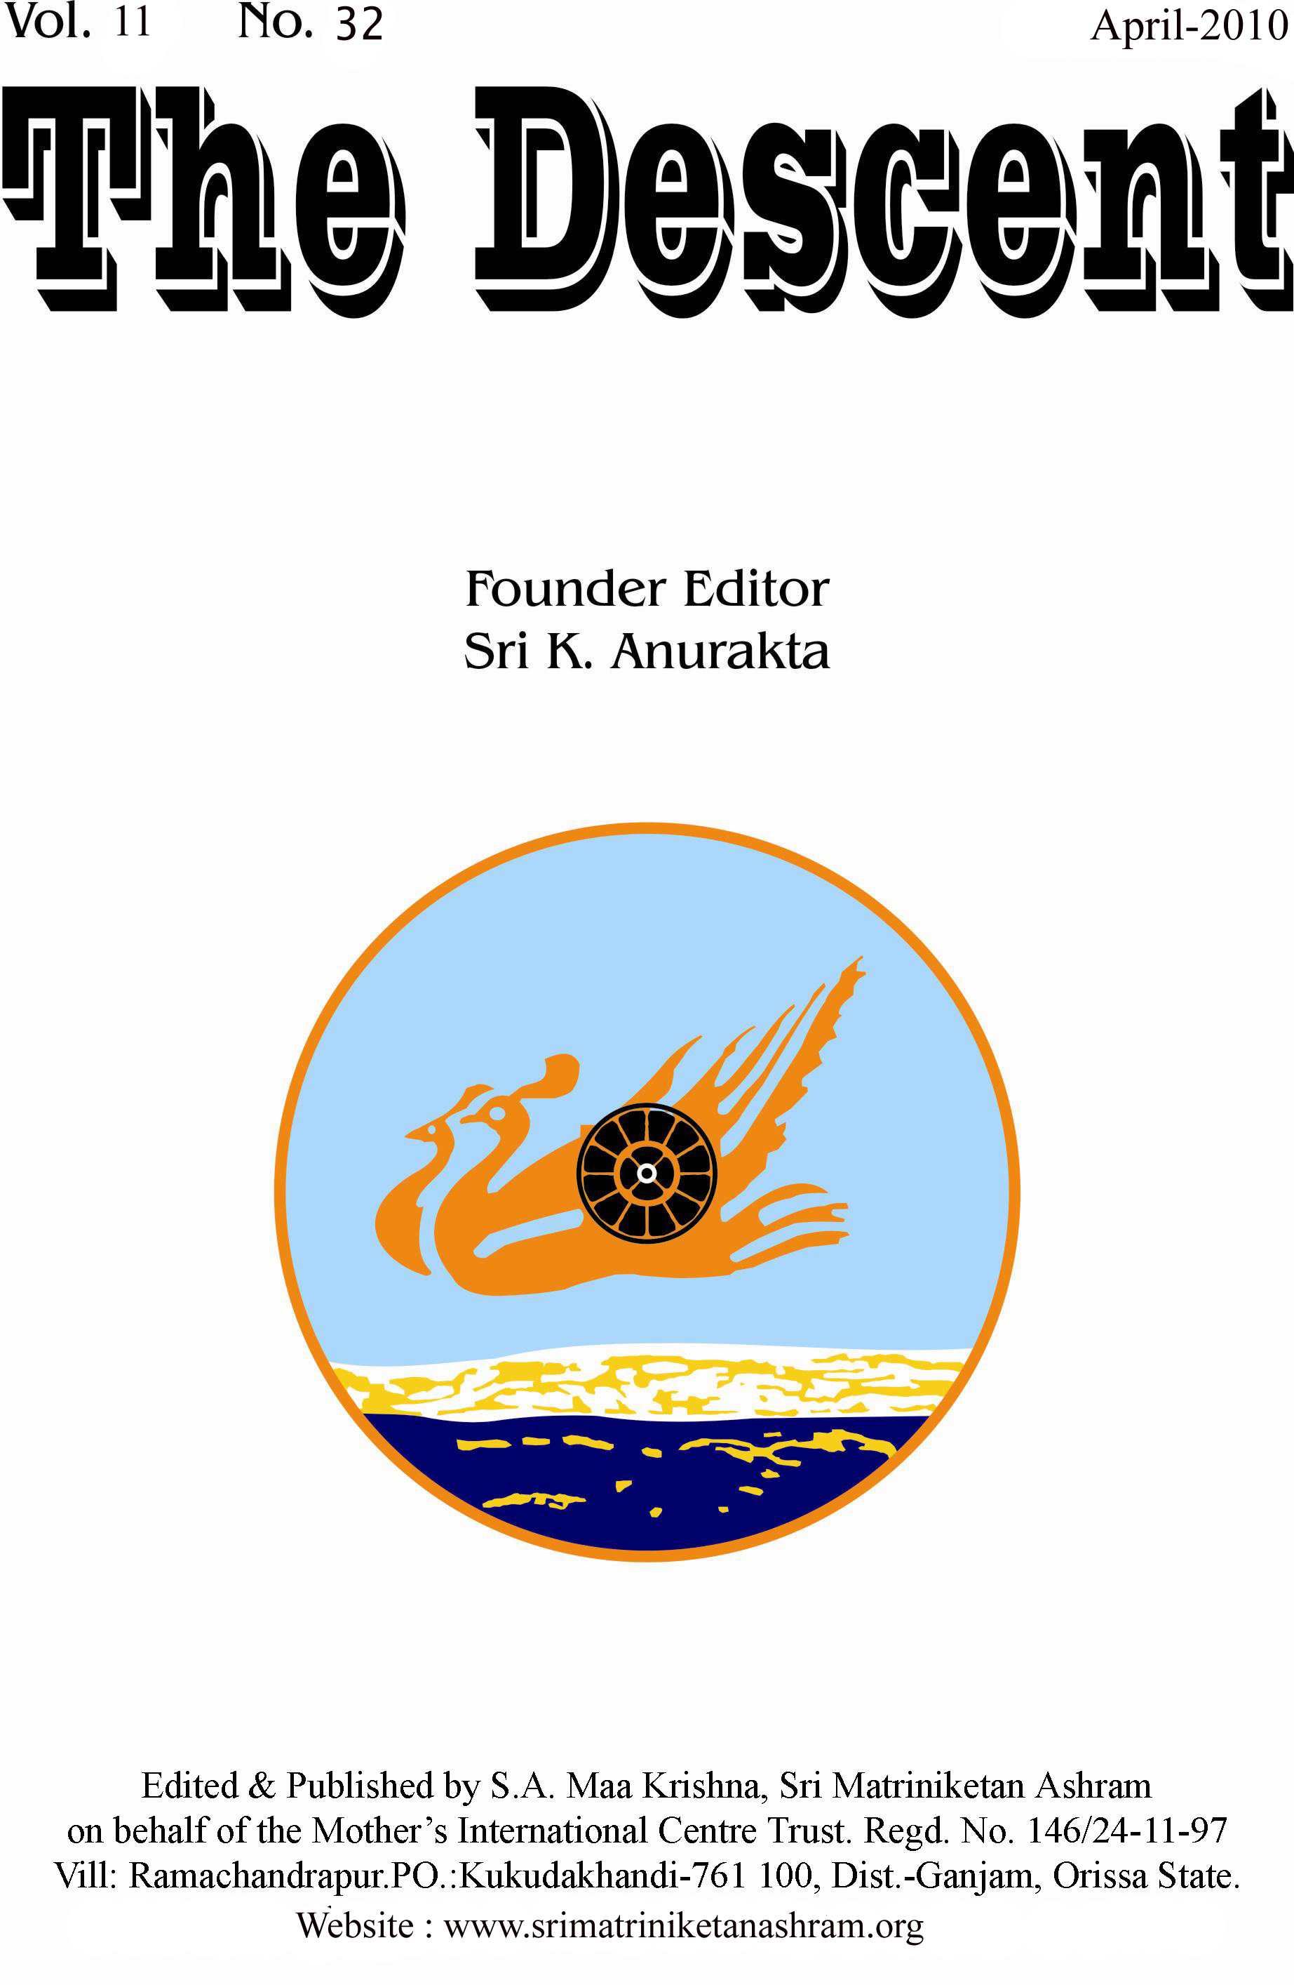

THE DESCENT

8

Vol. 11 No.32 Founder Editor–Sri K. Anurakta April- 2010

(This issue is offered at the lotus Feet of The Mother and Sri Aurobindo on occasion of Darshan Day, the 90th anniversary of The Mother’s final arrival to Pondicherry, 24.04.2010. This paper concentrates the pioneering action of the ‘sun-eyed children’ who succeeds the mortal birth of the mighty Mother in Her world play.)

A PLAYMATE IN THE MIGHTY MOTHER’S GAME

Our sweet and mighty Mother was not there
Who gathers to her bosom her children’s lives,
Her clasp that takes the world into her arms
In the fathomless rapture of the Infinite
The Bliss that is creation’s splendid grain
Or the white passion of God-ecstasy
That laughs in the blaze of the boundless heart of Love.
Savitri-286

The agenda of the Divine Mother, which She holds back from our sight, is to embrace and realize the Divine in Her own play and creation. Her greatness must act in every plane on earth, in heaven and in hell and She has a mighty responsibility of interfering, elevating and lifting every fixed fate and doom and cures the antithesis between heaven, earth and hell and compels Her playmate to en route the heaven’s gate through the shortcut passage of hell. Her secret and impossible task is to catch the boundless in the net of birth and cast the spirit in the physical form and lend speech and thought to the Ineffable and pushed to reveal the ever Unmanifest. Her self and all She was, She had lent to Her children to become conversant in their body’s lives so that the heaven might native grow on mortal soil. She came to help and save all the earth creatures, and to live with their grief and confront Death, Fate, Time and the riddle of man’s birth on Her way hewing towards Immortality. Her will has the capacity to alter and cancel the body’s destiny through free swift soul growth and fashion in the clay God’s perfect shape. Our present fixed fate is a child of past energies of blindness of our will in cosmic sequences and it can be our doom if the pace of the change is slow or we give the name of doom to our own choice. Her material birth was not meant to submit and suffer but to lead and deliver and Her soul’s issue was to win or lose the god like game for man thrown with Destiny’s dice. So by Her soul’s force She must dislodge Her past association, which stands as a block on the Immortal’s road and shape anew Her fate. The great World Mother in Her arose to reverse the fate’s cold dead turn, affirmed the Spirit’s tread on the surrounding, pressed back the dire senseless revolving wheels of Doom and She could bring oneness with the earth’s glowing robe of Light. She is a flaming warrior form the eternal peaks, empowered to force open the door denied and closed and established Her absolute Power in the Death’s kingdom and burst the bounds of Consciousness and Time.

The Divine Mother works as a mediatrix between the earth consciousness and Supreme Consciousness and we adore Her as ‘The Mother of all godheads and all strengths’⁴, ‘the Mother of all lives’⁵, ‘Mother of the universe’⁶, ‘a portion of the mighty Mother’⁷, ‘the Mother was she of Beauty and Delight’⁸, ‘Mother of works and force’⁹, ‘Mother of joy and peace’¹⁰, ‘mighty Mother of the worlds’¹¹, ‘The ancient Mother¹²’, ‘The infinite Mother’¹³, ‘the great Mother’¹⁴, ‘the world-Mother and the Bride’¹⁵, ‘a wonderful mother of the unnumbered souls’¹⁶, ‘And mother of thy wants’¹⁸, ‘the deep child like motherhood’¹⁹, ‘The universal Mother’s love’²⁰, ‘a mother draws her child to her arms’⁵¹, ‘Our sweet and mighty Mother’²³. Thus there is no end to Her attributes. She is housed in the atom and buried in the clod and when She is most unseen, most mightily She works.

Sri Aurobindo observed that Savitri, the Eternal Mother of All Time, All Soil, All People, All Scene, All Clime and All Life, always lives in earth’s atmosphere physically through one or ‘too few in mortal forms’⁵¹ and ‘A force in her that toiled since the earth was made’²⁴ and when the earth will be ready for supreme transformation ‘The Mighty Mother shall (again) take birth in Time’¹⁷. In Savitri we also find the representative symbol of a dynasty of self-ruling Mothers as ‘high divine successor’⁵² who are ‘citizens of that mother state’²² or ‘virgin bridals of the dawn’²⁷. Earth can be transformed into equal heaven or heaven’s joy might have been earth’s, when all humanity is fit to become the ‘god revealed as Krishna and Kali, the happiest boy and strongest girl of the crowd’⁵⁸ and this will liberate earth from subjection and failure of the earlier human love of Adam and Eve.
A Mother soul evolves like Savitri ‘among these tribes’⁴⁶ and burst open her divinity if she carries with her increasing Yoga Shakti through dynamisation of Divine Will, Knowledge and Love; she will be more powerful if she knows the ascending and descending stairs of Chetana Shakti through movement of exclusive, essential, multiple and integral Concentration; she will be the most powerful if she masters the four soul forces that of Brahmana, Khetriya, Vaisya and Shudra and four spiritual forces that of the Maheswari, Mahakali, Mahalakhmi and Mahasaraswati aspect of the Matri Shakti and she will be more than the most powerful if she retains Her Virgin Mother Power and arrests the wheels of Doom of the individual, collectivity and the race through activation of Virgin Time, Virgin Fire, Virgin Sun and Virgin Earth. Those who can carry and hold Savitri’s absolute Force can never fall from the luminous track, never lose the white spiritual touch, trample the Death’s Law with their living feet and claim from the Time their will’s eternity and God’s uninterrupted Presence.
Or a Sadhaka soul of The Synthesis of Yoga, compresses his evolution through Yoga to enter direct contact with the Mother of psychic and higher planes and ascends his status to become a Sadhaka of The Life Divine, compresses his evolution in Ignorance through evolution in Knowledge or spiritual evolution; enters contact with the Mother of spiritual and higher planes, resulting in heightening of Consciousness to become the Sadhaka of The Mother, a life of entire consecration and gets the special opportunity to receive Her Overmental and Universal Presence in this life, realises the Timeless Mother who projects Herself into Time, further extends his sadhana to become a Sadhaka of Savitri, to extricate the Mother of all lives and all Time, the Supramental Mother. If this effort is further extended, he will be the Sadhaka of the Eternal beyond any written truth and masters the inexhaustible mystery of the Existence in its comprehensiveness and enters the source of existence, the Bliss Mother. A Sadhaka, who has transcended the highest hinted spiritual experiences of the above four books can wait to record his lyric of Divine Love experiences ‘in the mystic volume of Book of Bliss.’⁴⁴ The Book of Bliss can be the extension of The Mother’s last cellular transformation experience which rests on the foundation of ‘The dire delight that could shatter mortal flesh’⁴⁷.

When Sri Krishna, the Master Soul’s Love, attained momentum with Sri Radha, the Mother Soul and further extended this love to His manifestation, the Gopis, the opposition raised by the then humanity from within and without Brindavana or when The Mother, the living representative of Divine Consciousness whose heart’s strength could carry the grief of the universe entered communion with Sri Aurobindo, the living representative of ‘the godhead by which all can change’⁵³ along with the growing disciples and children, the living representative of earth’s problem of untransformed nature, the opposition faced by Him from within His Ashram and outside world are the eruption of revolt and hostility from earth nature against the Mother Consciousness. We also observe that The Mother had to wait forty-five years after Her material birth to get the recognition of Her Divinity and Motherhood though She was Divine Mother from Her birth and Her Divinity bloomed fully under the auspice of Sri Aurobindo’s Light and Love. When She first met Sri Aurobindo in Pondicherry, She saw the Eternal who suffered in a human form, signed the ‘salvation’s testament with His blood’⁵⁶ and discovered Her ultimate destiny beyond Her own body, in Sri Aurobindo’s being. Her Physical and Subtle Presence was rarest opportunity for Sri Aurobindo’s highest Integral Realization and special privilege for the children to get the protection against the lower vital urge, the source of greatest trouble, identified as the ‘harlot (mother) Power’²⁵ and liberation from constructing mind, identified as the ‘barren mother’²⁶ and She continues Her effort to transform the maimed vital desire and maimed mental achievements into Divine sweetness and Integral fulfillment and deliver the heart and mind from all twilight thought. The entry in to the Direct contact with The Mother in the subtle physical realm is the widest possibility available for the greatest number of conscious humanity.

A Sadhaka of Integral Yoga foresees in the worm ‘the coming god’⁴⁰ who climbs slowly from the plasm to immortality in All Life and if he can change the pace of this slow ascension towards constant, high, comprehensive and instantaneous transformation then only the earth’s last salvation can come where all is known and clasped by Love and unity and doom could be left to sleep for all time and nobody would turn back to ignorance and pain. In this sense he can neither despise but adore the motherhood in a harlot, the representative mother of lower vital world, as the veiled Divine who bears in her heavy heart a large burden of earth’s darkness and black Idea to relieve the rest of humanity from ‘greater portion of churned poison of world ocean,’²⁹ nor can he abhor and terrify the ‘barren mother’, the representative mother of lower mind and sole creator of this apparent world, but by consecration and adoration he liberates her unreal child, this world of falsehood and the burden of dull and disgusting barren Time, nor can he remain indifferent to the ‘mother of seven sorrows’³¹, the representative mother of seven-fold Ignorance²⁶, the mother of the ‘barren and harlot mother’ but descends the divine force to this dangerous nether domain of Subconscient sheath. Lastly, he meets the Mother of Evil⁵⁹, a shape illimitable and vague, in the Inconscient Sheath who has many Sons of darkness preoccupied to make this creation a dangerous Hell and she sits on Death⁵⁹ who swallows all things born on this perishable earth. Each human soul is accepted as delegate of the Divine Mother, who chooses to watch, receive and actuate Her Supreme play through nether, intermediate and highest stations of inconscient, subconscient, physical, vital, mental, Psychic, Spiritual, Overmental, Supramental and Ananda planes. Our consecration to the Divine Mother can neither be sufficient nor can it be entire if we exclude the adoration of ‘thousand icons they have made of Her’⁴⁵ and All Mother of all Time, all Plane and all Life. When the Avatara, the incarnating Divine is caught by the Wheel of doom that He had hoped to break, His crucified voice proclaims, ‘I, I am God’⁵⁷, during that critical moment of death the Heaven reminds Him with equal cry, ‘Yes, all is God.’⁵⁷ If a seed grows into flower of Godhead in the world tree then all shall discover God in self and things.

The norms of Integral Yoga proposes that a Sadhaka’s adoration of the Transcendent, identified as Vedantic Sacrifice, is not complete ‘if it is not offered to him wherever he manifests or wherever even he hides his godhead—in man and object and every creature’¹, identified as Vedic Sacrifice. All creatures are ‘seen and felt as the Divine manifested in many disguises’². This adoration is equally received by the Supreme when directed towards ‘our fellow-creatures or to lesser Powers and Principles’⁴⁸ and extended even towards the worship of god, idol, human magnets and human Leaders⁵⁰ as ‘steps through which the human race moves towards that blissful passion and ecstasy of the Infinite’⁴⁹. Integral Yoga provides further guideline to obey, worship and adore the Divine in the Guru⁵⁰, Avatara and ‘Divine personality’³ in three successive gradations that in which a Sadhaka is capable to discern the particular form, catholicity and quality of the Godhead of which He is a living representative; secondly, He is the one real Person, the All-Personality, the Ananta-guna and not divisible by any sect, creed, schools of thought and Nationality etc. and thirdly, we get back to the ultimate source of all idea and fact of personality in which He is considered as one with the Absolute, the Purushottama.

How can a Sadhaka be ‘playmate in the mighty Mother’s game’²¹? That is the secret of ‘wedding of the Eternal Lord and Spouse’⁵⁴ and ‘Long romance of Thee (the Divine Mother) and Me (Supreme)’⁵⁵ in our heart. The secret of becoming the Ishwara, one with the Vasudeva, who is all, is revealed in the Gita. The highest secret, rahasyam uttamam²⁸, of becoming cosmic Divine as hinted in the Gita is further developed and perfected by Sri Aurobindo into four stages of Supramental experiences beyond the written truth that of (1) secret all-inclusive knowledge, guhya³² vijnana, and corresponding Supramental transformation, sadharmyam³³, (2) more secret all-inclusive knowledge, guhyataram³⁴ vijnana, and the corresponding transformation of Sva Prakriti³⁵, (3) the most secret all-inclusive knowledge, guhyatamam³⁶ vijnana, and the corresponding Divine nature, Madbhavam³⁷, and (4) more than the most secret all-inclusive knowledge, sarva guhyatamam³⁸ vijnana, and corresponding supreme Nature, Param bhavam³⁹.

Each of these Supramental experiences strengthens the Ishwara’s active relation with Ishwari resulting in corresponding leap in earth’s grand and high spiritual destiny. The Ishwari’s active love with the Ishwara in Supramental plane becomes most powerful, pure, rare, profound and intense of all divine energies when She throws Herself into nether land of Subconscient and Inconscient sheath, far from the child God Krishna fluting to rapture, a long seclusion of inner woodlands with passive silence and passive love, biraha; Her isolation will necessarily give a determination and formation to the Divine creation and manifestation and build in the abysm a road for Heaven’s descent. This Ishwara-Shakti and Brhaman-Maya realization of active and passive Divine union, one of the Suffusion of Supramental Being into higher and lower Nature and the other of the melting of lower Inconscient and Subconscient Nature in the higher Supramental Self, can bring participation in the discovery of total dynamism of the Transcendent by whose descent ‘this world and self will be empowered to break their disguising envelopes and become divine in revealing form and manifesting process as they now are secretly in their hidden essence.’³⁰ Thus the gulf between the Eternal and Abyss is reconciled to mingle Matter and Spirit and realize their utter Oneness.

And the most unique part of this Divine Mother’s Play is to participate in Her spiritual experience of the Spirit traveling back⁴¹, back to the yoke of ignorance, fate and stress of mortal unnumbered past lives or ‘A mighty Hand then rolls the mind’s firmaments back’⁴² and ‘Her mind moved in a many-imaged past’⁴³ to alight the pathway through strange symbol dreams and thus Nature steps into the eternal Light. Eternal Night is the shadow of the Eternal Day. Night is conquered by that feeble beam, its faint infiltration drills the blind deaf mass. A golden fire came in and burned the Inconscient Night and only few black remnants stained that Ray. Then in Her Divine Play the dream of nether life is ended and earth experiences Her final Victory.

OM TAT SAT
Reference:
1: CWSA-23/The Synthesis of Yoga-159-160, 2: CWSA-23/The Synthesis of Yoga-165, 3: CWSA-23/The Synthesis of Yoga-381-382, 4: Savitri-313, 5: Savitri-525, 6: Savitri-345, 7: Savitri-486, 8: Savitri-525, 9: Savitri-513, 10: Savitri-520, 11: Savitri-528, 12: Savitri-551, 13: Savitri-561, 14: Savitri-628, 15: Savitri-691, 16: Savitri-695, 17: Savitri-705, 18: Savitri-720, 19: Savitri-723, 20: Savitri-8, 21: Savitri-60, 22: Savitri-262, 23: Savitri-286, 24: Savitri-19, 25: Savitri-185, 26: CWSA-21/The Life Divine-512, 27: Savitri-401, 28: The Gita-4.3, 29:SABCL-17/The Hour of God-94, 30: CWSA-23/The Synthesis of Yoga-170, 31: Savitri-503, 32: The Gita-9.2, 11.1, 33: The Gita-14.2, 34: The Gita-18-63, 35: The Gita-9.8, 4.6, 36: The Gita-9.1, 37: The Gita-8.5, 10.6, 13.18, 38: The Gita-18.64, 39: The Gita-9.11, 40: Savitri-23, 41: Savitri-09, 42: Savitri-154, 43: Savitri-11, 44: Savitri-232. 45: Savitri-276, 46: Savitri-6, 47: Savitri-237, 48: CWSA-23/The Synthesis of Yoga-107, 49: CWSA-23/The Synthesis of Yoga-159, 50: CWSA-23/The Synthesis of Yoga-130, 51: Savitri-372, 52: Savitri-,344, 53: Savitri-397, 54: Savitri-411, 55: Savitri-699, 56: Savitri-445, 57: Savitri-446, 58: SABCL/17/137, 59: Savitri-222.

THE DESCENT
Edited and Published by S. A. Maa Krishna, Sri Matriniketan Ashram, for The Mother’s International Centre Trust, Regd. No.-146/24.11.97, At- Ramachandrapur, Kukudakhandi-761100, Dist.-Ganjam, Orissa, India. E-mail: samaakrishna@gmail.com, www.srimatriniketanashram.org

